GS105D Korisničke upute
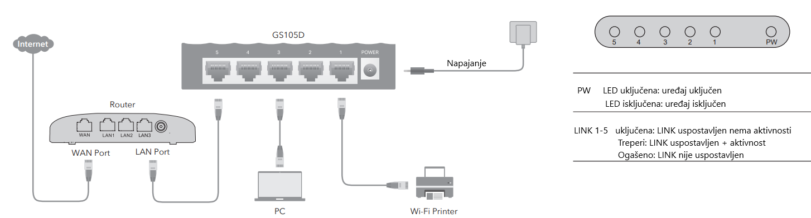
Standard: EEE802.3 10Base-T,IEEE802.3u 100Base-TX, IEEE802.3ab 1000Base-T,IEEE802.3az
Kabel: 10BASE-T: UTP kategorija 3,4,5 kabel (maksimum 100m) 100BASE-Tx: UTP kategorija 5, 5e kabel (maksimum 100m) 1000BASE-T: UTP kategorija 5e, 6 kabel (maksimum 100m)
Broj portova: 5 x 10/100/1000Mbps Auto-Negotiation portovi
LED indikator: Napajanje, LINK/ACT
Metoda prijenosa: Store-and-Forward
Kapacitet: 10Gbps
Ulaz napajanja: DC 5V/0.5A
Potrošnja: max 2.3W
Frame Filtering i Forward Rate: 10Mbps: 14880pps 100Mbps: 148800pps 1000Mbps: 1488000pps
Dimenzije: 100*69*24 mm
Radna temperatura i vlaga: 0℃-40℃, 10%-90%
Temperatura i vlaga skladištenja: -40℃-70℃, 5%-90%

